

**PETERSTON SUPER ELY CHURCH IN WALES**

**PRIMARY SCHOOL**

**YSGOL LLANBEDR Y FRO**

***Website: www. peterstonprimary.net***

**Croeso-Welcome**

Dear Parent/Guardian,

Welcome to our school, choosing the right school for your child is very important. Parents want a good education for their children, but they also want them to be happy and to feel safe and secure. At Peterston super Ely CIW Primary, we believe we can offer all these things. We pride ourselves on the broad and balanced curriculum, which we offer to our pupils, the pastoral care we provide and the feeling of community, which exists, within our school.

The school is a Church in Wales Voluntary Controlled School, which means that although it is a Church school, Vale of Glamorgan Education Authority maintains it. Our Section 50 report of February 2013 stated that the strengths of the school were, “its strong Christian character, the pupils’ attitudes to the Christian values of the school and its relationships with the local priest, church and local community.”

Peterston super Ely CIW Primary Estyn Inspection report of February 2013 stated, “by the time pupils leave the school their performance in literacy and numeracy is good and at times it is excellent. Across the school, nearly all pupils make good progress and achieve or exceed their targets. Teaching is consistently good in all classes.”

This booklet is intended as a guide for parents. It briefly states the organisation of the school and its broad aims and objectives. It serves also as a practical reminder regarding information to which parents may need to refer to from time to time. Much of the information in this booklet is available in far more detail in school policies, all of which are kept in the school office and on the website. They can be viewed and discussed with prior arrangement with the Headteacher.

Families who are considering sending their children to Peterston are encouraged to visit the school to see for themselves all that we have to offer. Please do not hesitate to contact me for any further information or to arrange a school visit.

We look forward to welcoming you to our school.

Yours sincerely

Mr Owen Turner

Headteacher

Peterston super Ely CIW Primary

Heol Llanbedr

Vale of Glamorgan

CF5 6LP

Telephone: 01446 760328

Email: [Peterstonps@valeofglamorgan.gov.uk](mailto:Peterstonps@valeofglamorgan.gov.uk)

**PETERSTON SUPER ELY CHURCH IN WALES PRIMARY SCHOOL**

|  |  |
| --- | --- |
| **CONTENTS** | **PAGE** |
| Welcome Letter | 1 |
| Contents | 2 |
| Vision Statement | 3 |
| Church in Wales Mission Statement | 4 |
| Staffing | 5- 6 |
| Class organisation | 7 |
| Aims of the school | 8 |
| Admissions policy | 8-9 |
| Prospective pupils | 9 |
| Parental support | 9 |
| Extra curricular clubs | 10 |
| Sports | 11-12 |
| Breakfast club | 12 |
| After school club | 12 |
| Invitations to school | 12 |
| Communication with parents | 13 |
| School uniform | 14 |
| School absences | 14 |
| Lunchtime | 14 |
| School hours | 16 |
| School term dates | 16 |
| Transport arrangements | 16 |
| Cycling to and from school | 16 |
| Parking | 16 |
| Curriculum | 19 |
| Religious education | 20 |
| Additional Learning and Educational Needs | 21 |
| Looked After Children | 21 |
| More Able and Talented | 22 |
| Equal opportunities | 22 |
| Disability equality | 22 |
| Homework | 23 |
| Testing and assessment | 23 |
| Reporting to parents | 24 |
| Complaints policy | 24 |
| Charging policy | 24-25 |
| Code of behaviour | 25 |
| Anti bullying | 25 |
| Child protection/safeguarding | 25 |
| School premises | 27 |
| Pupil Voice/Schools council | 27 |
| PTA | 26-27 |
| Attendance | 27 |



**Ysgol Llanbedr Y Fro**

**Peterston super Ely Church in Wales Primary School**

**www.peterstonprimary.net**

**Vision Statement**

**“Learning and growing together, to become the best we can be.”**

***Our Vision***

To work as a Christian family to enthuse and equip, independent life-long learners.

***Our mission is to help pupils …***

* Grow spiritually, emotionally and academically
* Develop strong, healthy enriching relationships and attitudes
* Realise and reach their full potential
* Experience high quality teaching
* Recognise that they are special and unique in the sight of God
* Build their understanding of the responsibility they have to make difference to the world and to be agents of change
* Express their ideas thoughts and emotions creatively

***We will …***

* Equip pupils with knowledge, skills and dispositions for life-long learning
* Create a breadth of experiences catering for a full range of interests
* Encourage engagement with all stakeholders
* Form an environment that nurtures and develops
* Establish a culture of learning for both pupils and staff

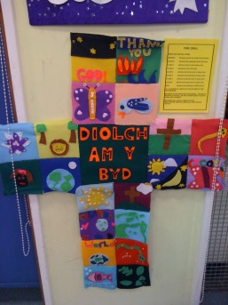

**PETERSTON SUPER ELY CHURCH IN WALES PRIMARY**

**This is our Voluntary Controlled Church in Wales School**

**School’s Mission Statement**

The Bishops of the Catholic Church and the Church in Wales are agreed that every school should be a special place, a safe place, a place of learning, a place of nurture and of exploration. In our school, we demonstrate openness and acceptance, tolerance and forgiveness. In our school, values and attitudes are formed and every individual is celebrated as unique.

We develop the distinct Christian Character through our religious teaching, collective worship and ethos that makes God’s love and presence known to the world.

**Our Church school is a place of mission and witness to the Gospel.**

* Where Jesus Christ is our foundation;
* Where every person has equal value and the chance to grow and develop to their full potential;
* Where teachers, staff, governors and parents, are committed to the education and development of the whole person;
* where the search for knowledge is accompanied by a quest for faith and a journey of spiritual experience;

…so that…

* every child can learn of the richness of the created world, and grasp every opportunity to contribute to it in life;
* every member of staff can be nurtured in their vocation to teach;
* every achievement can be celebrated and every shortcoming forgiven;
* every person in this school can know that they are made in the image of God.

The school is a Church in Wales Voluntary Controlled School, which means that although it is a Church school, it is maintained by Vale of Glamorgan Education Authority.

**GENERAL DETAILS**

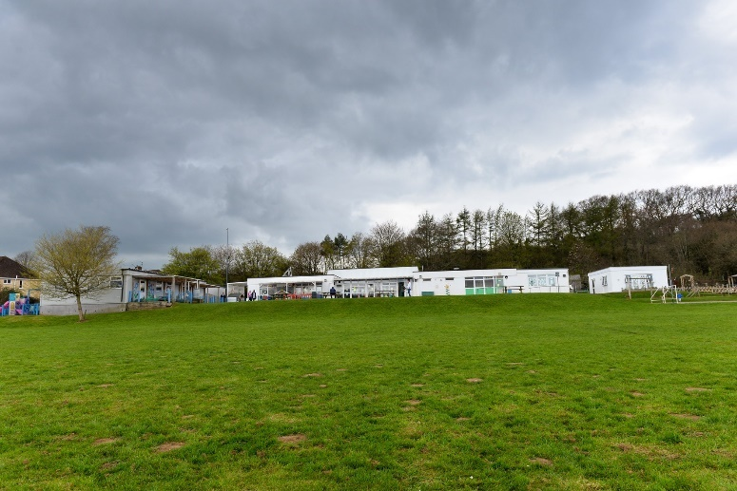

There has been a village school in Peterston for more than 100 years, so we carry on a long tradition of excellent education, while playing a central part in village life. Peterston is a friendly, socially active village with first class facilities and within easy reach of Cardiff and Cowbridge. Situated in a cul-de-sac in the centre of Peterston, the present building was opened in 1974 and is all on one level with easy access for all children, including those in wheelchairs. It is surrounded by a pleasantly rural, large field providing games pitches, playing areas and a wildlife/ conservation area.

In 2004 we were able, with the support of the P.T.A, to build a two classroom extension at the end of the existing school building. The Archbishop of Wales also officially opened our new Nursery building. In 2012 we were able to build another classroom with the support of the parents and governing body; this has enabled us to increase the footprint of the school and has given us a classroom to use for peripatetic teaching and small group work.

The school has close links with local community groups, to the benefit of us all. It is a feeder school for Cowbridge Comprehensive School and The Bishop of Llandaff High School, which both enjoy excellent results. Admission to the Bishop of Llandaff High School is governed by strict criteria laid down by their Governors and a copy of this is available from the Headteacher at Peterston.

The school is a Church in Wales Voluntary Controlled School, which means that although it is a Church school, it is maintained by Vale of Glamorgan Education Authority. Its Governing Body is therefore a balance comprising church, local authority and parent representatives. At present, there are 15 members made up as follows:

|  |  |
| --- | --- |
| Mr R Bailey - **Chair** | Vale of Glamorgan Education Authority |
| Mr M Gabriel | Vale of Glamorgan Education Authority |
| Mrs L Cross - **Vice Chair** | Vale of Glamorgan Education Authority |
| Mrs D Powell | Community Council Representative |
| Mr N Jones | Community Council Representative |
| Mrs M Saal | Diocesan Council for Education |
| Mrs M Evans | Diocesan Council for Education |
| Mr O Turner | Headteacher |
| Mrs V Andrew | Teacher Representative |
| Mrs D Matthews | Non-Teaching Representative |
| Fr. M Davies | Ex-officio Foundation |
| Mrs H Mathias | Parent |
| Mr J Kuck | Parent |
| Mr S Evans | Parent |
| Mrs J Crichton-Smith | Parent |
| Mrs P Hunter | Clerk to the Governing Body |

**STAFFING**

Our school is a small, rural village primary; this academic year we have 160 full time pupils and 27 part time pupils in our Nursery. Much of the teaching is in groups, a method we have found beneficial, as each child is encouraged to progress to their potential.

For 2021/22- Our teaching staff at present is as follows:

Mr O TurnerHeadteacher

|  |  |  |
| --- | --- | --- |
| Name | Class | Role |
| Miss L Hallett | Y6 | Class Teachers |
| Mrs H Price | Y5 |
| Mrs L Johnson | Y4 (0.2) and Y3 (0.2) |
| Mrs R Glover - ***Deputy Headteacher*** | Y4 (0.8) |
| Mrs V Andrew - ***Senior Leader TLR*** | Y3 (0.8) |
| Mrs Hadall | Y2 |
| Mrs K Sully ***- ALNCo Senior Leader TLR*** | Y1 |
| Mrs T Jones - ***Senior Leader TLR*** | Reception (0.5) |
| Miss K Tingay - ***Senior Leader TLR*** | Reception (0.5) |  |
| Mrs C Incledon | Nursery (0.5) | Nursery Leader |
| Mr G Spencer | (0.8) | PPA Leader |

In addition, the following assist the teaching staff:

|  |  |
| --- | --- |
| Name | **Learning Support Assistants** |
| Mrs S Maynard |
| Mrs J Williams |
| Mrs A James |
| Mrs L Funtek |
| Mrs S Pitcock |
| Ms M Jones |
| Mrs D Matthews | School Administration Officer |
| Mr S Andrews | Caretaker |
| Mrs Y Thomas | School Cook / Breakfast Club Supervisor |
| Mrs S Newton | Kitchen Assistant |
| Mrs H Channing | Kitchen Assistant |
| Mrs S Jenner | Breakfast Club Supervisor |
| Mrs G Bennett | **Midday Supervisors** |
| Mrs C Incledon |
| Ms M Jones |
| Mrs S Clarke | School Crossing Patrol |
| Mrs Welch | Piano - Private |
| Mr A Ackland | Guitar - GMS |
| Mr I Nash | Drums - CAVMS |
| Mrs S Welch | Voice - Private |

**CLASS ORGANISATION**

The class organisation for 2021/22 is:-

|  |  |  |
| --- | --- | --- |
| **Class** | **Teacher** | **No. of Children** |
| **Nursery** | Mrs Incledon | 27 (morning only) |
| **Reception** | Mrs Jones/Miss Tingay | 11 children |
| **Year 1** | Mrs Sully | 18 children |
| **Year 2** | Mrs Hadall | 22 children |
| **Year 3** | Mrs Andrew/Mrs Johnson | 27 children |
| **Year 4** | Mrs Glover/Mrs Johnson | 26 children |
| **Year 5** | Mrs Price | 29 children |
| **Year 6** | Miss Hallett | 27 children |
| **PPA cover** | Mr Spencer (SuperStars) |  |

**Average class size = 22.5**

It should be stressed that organisation varies from year-to-year and up-to-date information is available on request.

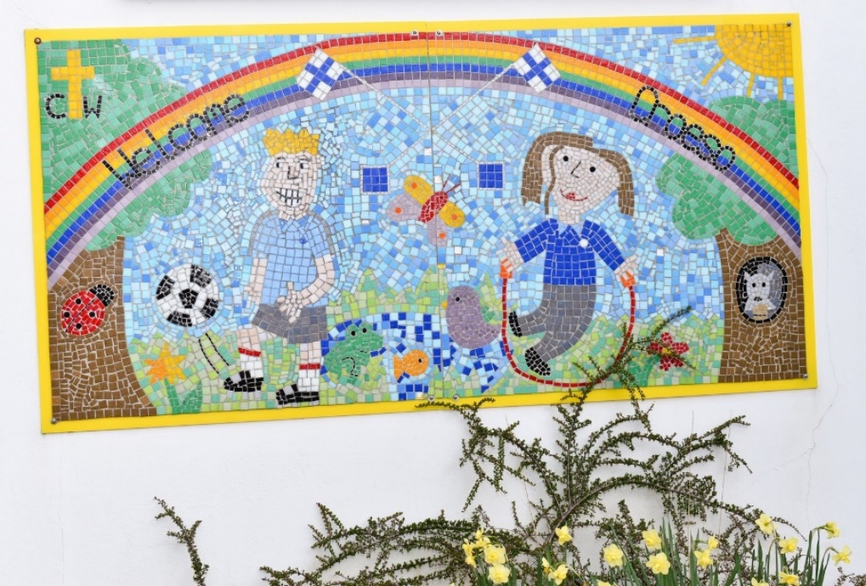

***Learning and growing together, to become the best we can be.***

**AIMS OF THE SCHOOL**

We aim to create a safe, friendly and happy environment for our children. We hope that they will be able to develop spiritually, physically, academically and socially as part of an extended and caring school family.

As the school is of Church Foundation, the promotion of Christian values and beliefs figure prominently, and the school maintains close contact with the parish church and its priests.

The school has adopted the county's policy on multi-cultural education and therefore encourages our children to live harmoniously with, and to have an understanding and respect for, all their fellow citizens.

We believe that, from the very first day your child starts school, we become partners with you in your child's education. The success or failure of a child at school depends on this relationship and to further this, we maintain an open policy in the school, and twice a year parents are formally invited to school to view their children's work and to speak to the teachers, there is also the opportunity for an informal open afternoon called “Proud to Present Peterston” where pupils can share their success with their parents. There are also many more informal contacts at concerts, special assemblies, parents' meetings etc. Everyone is encouraged to express any anxieties and parents are welcome to make appointments to see teachers to discuss any difficulties.

Please find within this prospectus a copy of our Home/School agreement. Our aim is to ensure we all work together in partnership. We are working towards developing the best learning environment and opportunities for your child. Please spend some time discussing the agreement with your child before sending it signed back into school.

We look forward to working in partnership with you and your child for many years to come.

**ADMISSIONS POLICY**

Currently our admissions number is 27 in each year group. Our admissions are controlled by the Local Authority.

Pupils can be admitted to the nursery on a part time basis the term after their third birthday and must attend for five half days.

Children are admitted to the Reception class, in the main school in the beginning of the school year in which they have their fifth birthday.

**Evidence of a permanent residence of a child must be supplied if required.** In the event of over-subscription by applicants from this category alone, the following criteria set out below, in order of priority, will be applied to produce an order of preference;

**1. a)** Children who have an elder brother or sister in attendance at the school during the academic year in which the child is to be admitted. (Where preferences exceed places available, the council determines priority by reference to the age of the pupils’ youngest sibling in the school, the youngest commanding the highest degree of priority).

**1. b)** Children in chronological date of birth order, the oldest being admitted first. If two or more children have the same date of birth priority will be given to children living nearest the school as measured by the shortest available walking route, those living nearest will have priority. The council uses a Geographical Information System (GIS) to calculate home to school distances.

**2 a)** Children in respect of whom the Council judges that there are compelling medical or social grounds for their admission to a specified nursery school/class i.e. those children recommended for placement with regard to medical, psychological or special education reasons, including looked-after children

* We have a full Accessibility Policy which outlines the full suitability of the school with regard to access for disabled pupils.
* It must be highlighted that Attendance at a Nursery Class does not automatically entitle a child to a reception class place in the same school.

Within the Vale of Glamorgan Parental guidance document which you can find on their website it will detail the closing date for applications the guidance document is entitled, “Educating Children in the Vale of Glamorgan – A parental Guide to School Admissions in the Vale 2022-23” that will be distributed to parents during the autumn term 2022.

Our Admissions policy is based on the Local Authority policy and is available to download from our website.

**PROSPECTIVE PUPILS**

Parents of Nursery and Reception intake children are invited to the school prior to starting in school. A meeting with the class teacher and the Headteacher is held in July or previous to this to discuss arrangements for September. All the children who are to be admitted to school, visit during the summer term and spend at least one morning in their future classroom. This is a valuable pre-school experience and one which we feel helps the children to feel at home in their school.

Parents considering transferring children from other schools to Peterston are encouraged to view the school.

**PARENTAL SUPPORT**

We have a thriving Parent Teacher Association of which you are automatically a member as a parent. All parents are encouraged to take an active part in the work and activities of the Parent Teacher Association, for without this parent/ teacher co-operation, we would be a poorer school in many ways. The PTA raises money for equipment and materials and many parents also volunteer to be helpers within the school. The PTA’s social events have become an integral part of village life and are a great opportunity for you to become part of that community.

There is a register of parent helpers who are able to give some time to the school in various ways and we hope that you will feel able to share some of your expertise with us in similar ways. All parent helpers will be required to undertake a DBS check prior to helping within school.

**EXTRA CURRICULAR/ SCHOOL CLUBS**

We have many thriving activity clubs taking place at lunchtime or after school hours. These are run by a combination of staff, parents and external agencies to whom we are very grateful and many children attend the clubs. We send out a timetable of clubs, times and age groups at the start of every academic year.

**Gardening Club** is run for children from Year 3 upwards where they meet at lunchtime and it is supervised by ex-parents of the school. Activities include cultivating the vegetable garden and plant troughs as well as carrying out maintenance on the whole outdoor classroom area. In the autumn term, a favourite activity is raking the leaves and composting them for use in later years. When wet, the club moves indoors, and plants seeds and bulbs or creates flower arrangements for Mothering Sunday and other occasions.

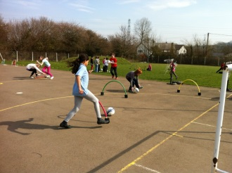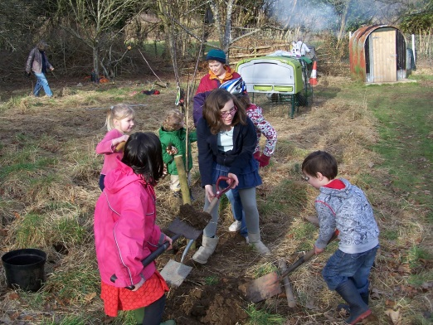

**Music Groups** Peripatetic music teachers visit the school weekly to teach violin, guitar, woodwind, keyboard, percussion and brass instruments. This service is provided by The Cardiff and Vale Music Service, Glamorgan Music School by private arrangement with parents. Recorder tuition is also provided for children from year 3 upwards. Children perform in groups at assemblies and special occasions such as Harvest Festival, Christmas concerts and the Leavers' Service. Musical instruments are available to borrow.

**Sports Clubs**

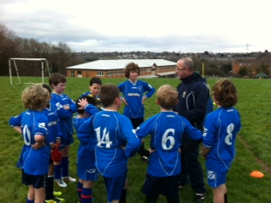The school has active football, rugby and netball clubs. We encourage all children to participate in a range of sporting activities regardless of ability – the taking part is as important as the winning! We also provide extra clubs run by external providers after school to cater for a variety of ages. The pupils also take part in “five a day” keep fit sessions at the start of each school day.

**School Choir** We have both a Foundation Phase and KS2 choir who will regularly perform at events in the school calendar such as the Christmas and Summer Fair.

**School Council** Our Schools Council are elected by their class each year and meet regularly throughout the year to improve aspects of the school alongside organising theme days, raising money for charities.

**SPORTING AIMS**

Peterston Super Ely Primary School is a very active school and sport plays a significant part in school life.

Sporting opportunities are given to older pupils who can represent the school in many team sports; boys and girls can participate in skills sessions for football, rugby and netball. The netball team enters the Vale of Glamorgan Netball League and the football team the Cardiff & District School Football League. The football and rugby teams play friendlies against other schools. In the summer; coaching is available in tennis and athletics. Children have represented the school at athletics in individual events and relays at the Cardiff and District Championships held at Leckwith Stadium. There is a tradition of great enjoyment and success in these events.

The school has good facilities including attractive grounds, a sports field marked for winter and summer sports, two playgrounds marked with netball courts and active playground games.

We utilise specialist coaching – such as the Cardiff Blues and Cardiff Dragon Rugby whenever possible.

The children have the opportunity, after representing the school, of representing their district, county and even country. We have had children in recent years that have represented Cardiff and the Vale of Glamorgan County at football, rugby, athletics, and cricket. Some of our past pupils have also gone on to compete in the Olympics

We also run various sports clubs during and after school (please see clubs section of the prospectus). We also plan in regular “5 a day” keep fit sessions in every class. The school have also started the Daily Mile where children are encouraged to walk or run a mile every day. The physical and emotional benefits of this have been commented on by staff and pupils.



**OTHER PROVISION**

**Free Breakfast Club** We opened the Welsh Government funded Breakfast Club in September 2012. It is open from 8.05-8.50am each day based in the school hall. No drop in or casual facility will be available but a prior sign up agreement must be presented to the school prior to the next term. Information is available from the school office.

**Wrap Around Care and After School Club**

Simply Out of School operate a privately run childcare using our Nursery setting and this is available from 11.45 am -3.30pm for our Nursery pupils and then 3.30pm-6pm for all pupils. The Club has proved to be very popular and provides a range of exciting activities. Holiday clubs also run during some weeks of the school holidays

*More information is available from Simply Out of School at https://www.simplyoutofschool.co.uk*

**SPECIAL OCCASIONS**

Parents, members of the parish, governors and community members are invited to the following days:

**Class Worship** Each class leads class worship for parents to attend over the year. The Worship is based upon our values or Christian festivals.

**Church Visits** Visits are made by the school to St Peter's Church for a Eucharist Service each half term and on occasions we celebrate the Eucharist at School.

**Christmas Concert** One of the highlights of our school year; the Christmas concert sees our school hall packed to the hilt with parents, governors and villagers for a mixture of drama and music.

**St David's Day Eisteddfod** St David's Day is celebrated on March 1st with an inter-house Eisteddfod. Competitions, entered keenly by all our children, include art, written work, Welsh dramas, and musical items and culminates with the "Chairing of the Bard."

**Sports Day** The undisputed highlight of the Summer Term, our Sports Day is an inter-house competition of individual and team races, as well as old favourites like the parents’ race. We believe in the importance of physical activity and competition for all our pupils.

**Leavers' Ceremony** This is a moving finale to the year when we recognise the many achievements of our pupils and bid farewell and good luck to the Year 6 leavers.

**COMMUNICATION/INFORMATION YOU WILL RECEIVE AS PARENTS**

We feel it is vitally important to keep you informed about the school on a regular basis. We use an app and communication provider called SchoolComms which you will be able to set up once your child has started school. This allows us the send messages to you and for you to contact the school to inform us of any absence.

On a regular basis you can expect to receive the following:

1. A written report about your child's progress each year to supplement the open evenings.

2. A weekly newsletter informing you of events in school.

3. Full minutes of governors' meetings are available in school for parents to read. Agendas are put up on the notice board outside school for your information.

4. Annual Parents' Report of the Governing Body (AGM)

5. Parent Teacher Association newsletters and information about meetings, events etc.

**INFORMATION WE WOULD LIKE YOU TO GIVE US**

You will be asked to give us confidential details relating to your child when she/he enters school, including the name and address of your doctor. Some of this information may be stored on the school's administrative system. It will be kept purely for school use and will comply with the requirements of the Data Protection Act. We will also need to have contact telephone numbers in case of emergencies.

***Please make sure that any changes are notified to the school so that our records are kept up to date.***

We also need to know if problems occur at home. Even small events can affect the way a child behaves at school. We can only help your child if we know about any problems she or he might be experiencing. They might also experience problems whilst at school. Again, do let us know. We can only do something about it if we are kept informed.

**HEALTH**

The Health and Education Authorities work closely together for the benefit of your children. Our school nurse makes regular visits as do the dental nurse and the audio nurse.

On occasions, children will return to school before completing a course of prescribed medicine. Should it be necessary for staff to administer medicines, you will be asked to complete a form and to make sure that all medicines are in the containers supplied by the chemist and are clearly labelled with the child's name and dosage. All medicines will be stored in the office safe or the refrigerator.

If a child becomes ill or has an accident during the day, then we will act, as would caring parents. In the interests of the child, it may be necessary to request that she or he is collected from school or may be taken to hospital. In order to inform the parents as quickly as possible we use the contact telephone numbers given to us on arrival at school. It is therefore of utmost importance that both parents' and alternative numbers are kept up to date.

**SCHOOL UNIFORM**

The Governing Body strongly requests the wearing of our school uniform. The uniform is available to purchase from The Pencil Case, based in Cowbridge. The Schools Council choose three days a term which are non-uniform days where we raise money for a chosen charity. We encourage children to wear sensible clothing and black footwear at all times, bearing in mind the many and various activities that they will be involved in during the school day. School uniform in primary schools is optional.

The wearing of jewellery is discouraged on safety grounds. If earrings are worn they should be of the "stud" variety. Rings and necklaces are not allowed, as they are a danger to the wearer and other pupils during playtimes.

**It helps us greatly if clothes and possessions are labelled, particularly those of the younger pupils.**

For indoor physical education lessons, the FPh (infants) and KS2 (Juniors) should wear t-shirts and shorts or tracksuit bottoms. **We ask that pupils wear their P.E kit into school on the normal day for P.E.** Bare feet are encouraged for some sessions or a pair of trainers but for children with foot ailments, suitable light training shoes are advised.

For after school clubs, children are advised to have a change of clothing including a change of footwear for those playing football/rugby, however they are not essential.

If you have financial difficulty in purchasing school uniform we would be happy to speak to you confidentially. We regularly have “nearly new” uniform stalls run by the PTA.

**ABSENCES**

Due to government regulations, we need to know about absences for appointments in advance and about absences due to illness as soon as possible. We would therefore ask you to either to send a message via the SchoolComms app, a short note addressed to your child's teacher with the relevant information or to phone the school office.

We do not advise families to take holidays during term time, unless in exceptional circumstances; this is in line with Welsh Government guidelines.

For any holiday absence requests during the term time we have been asked by the Local Authority, to ask you to apply in writing prior to the holiday. The relevant forms are available from the school office.

We would strongly discourage you from taking any holidays in term time.

**LUNCHTIME ARRANGEMENTS**

A well prepared meal is available cooked in our own kitchen by our cook and her assistant. We are currently working with the Local Authority to improve upon the already very popular school dinners; our cook has one of the highest productivity rates in the Vale of Glamorgan. Our school meals comply with the Welsh Governments Appetite for Life guidelines and comprises of fresh produce.

The charge for a school lunch is currently £2.45 per day for all pupils.  Payment is to be *made in advance.*The majority of parents use our e-payment method to pay and this can be done online using a very secure website called ParentPay. All parents will be given an activation username and password on joining our school.  Alternatively you can pay in cash at local stores where you see the PayPoint logo.

Eligibility for free school meal entitlement is provided for parents who are in receipt of certain support payment. Some of the relevant support payments are: Income Support and Child Tax Credit (but not Working Tax Credit). Forms are available from Mrs Matthews in the School Office.

There are always four members of staff on duty, who supervise our children during the lunch break. The Headteacher or Deputy Headteacher will also be present during most lunchtimes to ensure everyone is happy and eating their lunch!



**Fruit Tuck Shop**

We are aiming to achieve Phase 4 of our Healthy Schools Award by the end of next year. We have a Fruit Tuck shop which is run four times a week by the Year 6 pupils who sell a wide range of healthy snacks to all pupils. Money for fruit is also paid via ParentPay. We have also set up a SNAG (School Nutritional Action Group) group to look at all aspects of “food and fitness “within our school. We have held parent workshops led by Vale Nutritionists in the year and send out leaflets to all parents regarding our healthy eating focus.

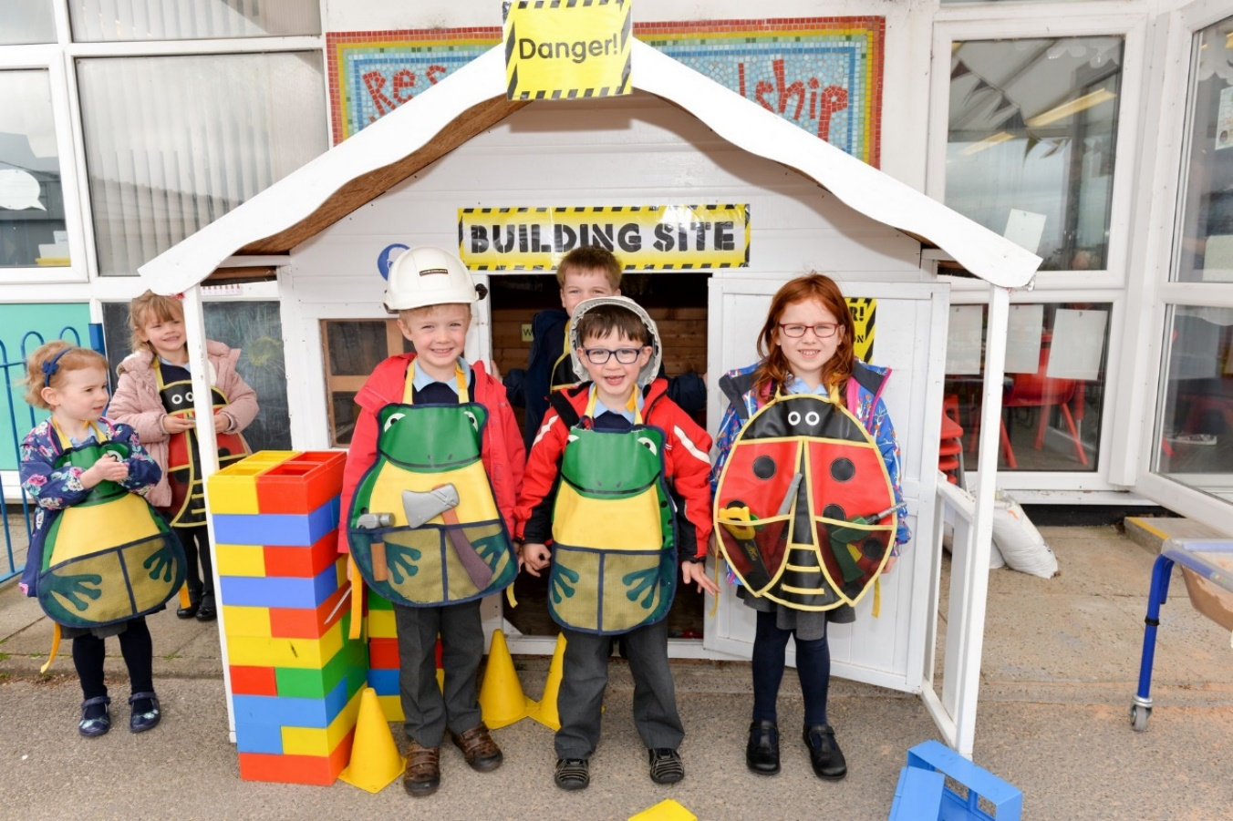

**SCHOOL HOURS**

|  |  |
| --- | --- |
| **Nursery (am only)** | 8.50am – 11.45am |
| **Foundation Phase**  **And Key Stage 2 morning session** | 8.50am - 12.00pm |
| **Foundation Phase**  **And Key Stage 2 afternoon session** | 1.00pm – 3.30pm |

There are two break times for pupils during the school day, one in the morning and one in the afternoon.

**SCHOOL TERMS FOR THE ACADEMIC YEAR 2021/22**

**Autumn Term 2021**

|  |  |
| --- | --- |
| **Start** | Monday 6th September 2021 |
| **End** | Friday 17th December 2021 |

**Spring Term 2022**

|  |  |
| --- | --- |
| **Start** | Monday 4th January 2022 |
| **End** | Friday 8th April 2022 |

**Summer Term 2022**

|  |  |
| --- | --- |
| **Start** | Monday 25th April 2022 |
| **End** | Monday 22nd July 2022 |

There are six INSET days that are taken at the discretion of each school for 2021/22

* Friday 3rd September 2021
* Friday 1st October 2021
* Friday 18th February 2022
* Monday 21st March 2022
* Tuesday 3rd May 2022
* Monday 6th June 2022

Please see the Vale of Glamorgan website for further holiday dates.

**TRANSPORT ARRANGEMENTS**

Free transport arranged by the Local Authority is only provided for Foundation Phase (Infant) children who live further than 2 miles from the school and for KS2 (Junior) children who live further than 3 miles from the school. Please see the school administrator, Mrs Matthews for further details.

Unfortunately, transport is not provided for those children who have chosen Peterston School, but who have a school nearer to them.

**CYCLING TO AND FROM SCHOOL**

It is recommended that children only bring their bicycles to school if they have completed the Cycling Proficiency Course satisfactorily. In all cases they should wear an approved safety helmet (BSI Kitemark). Responsibility for insurance of bicycles on school premises lies with the parents. The school provides an annual Cycling Proficiency Course for all children in Year 6.

**PARKING OF PARENTS’ CARS**

We would appreciate your help with parking cars whilst delivering and collecting children from school. The Three Horse Shoes pub car park has been made available to us at both these times. If, **for a special reason**, you have to park closer to school, please do not use the entrance to school or Heol Llanbedr (the road leading up to the school) as this causes dangerous congestion. **These arrangements are necessary to ensure the safety of our children and to maintain good relationships with our neighbours in the local community.**

**FURTHER INFORMATION**

Some of these documents are available on the Parents Page of the school website.

The following documents are available for inspection by parents:

1. The Curriculum Policy.
2. All statutory instruments, circulars and administrative memoranda which are sent to schools by the Welsh Office.
3. All published HMI reports that refer expressly to the school.
4. A full copy of the arrangements for the consideration of complaints about the school curriculum.
5. The Church in Wales agreed syllabus for Religious Education.
6. Copies of all Governing Body policies.
7. A copy of that part of the Trust Deed, which governs the provision of religious education and any other written statement which may have been prepared about arrangements for religious education.

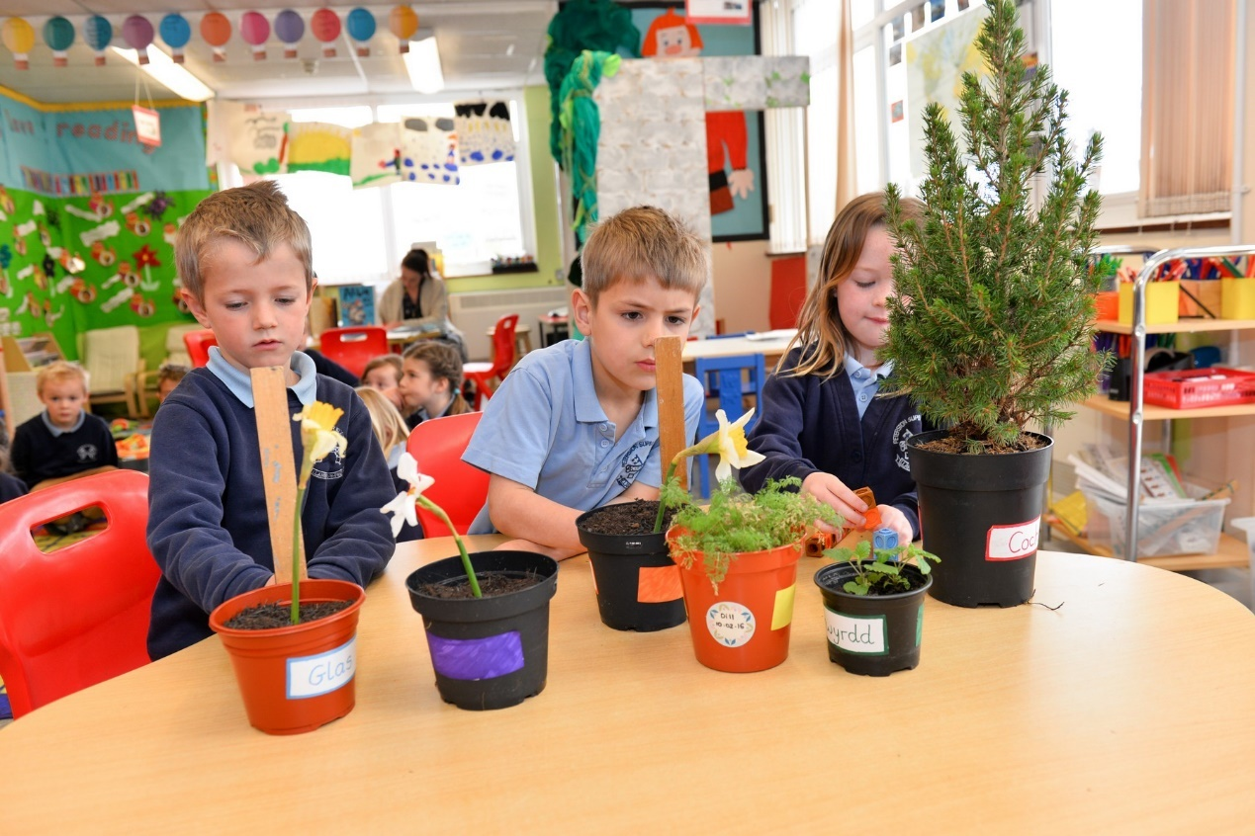

**THE CURRICULUM**

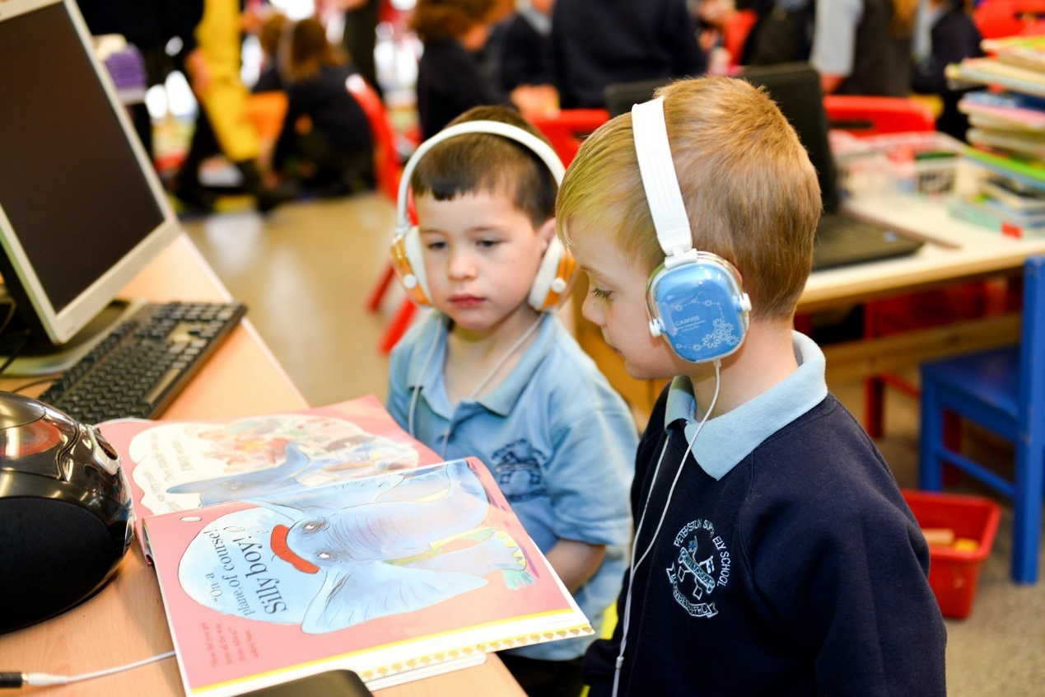

**GENERAL INFORMATION**

###### A new curriculum for Wales is being developed with education professionals across Wales with the aim of it being available to settings and schools by January 2020, and being used throughout Wales by 2022.

The whole approach to developing young people aged 3 to 16 will change.

The new curriculum will have more emphasis on equipping young people for life. It will build their ability to learn new skills and apply their subject knowledge more positively and creatively. As the world changes, they will be more able to adapt positively.

They will also get a deep understanding of how to thrive in an increasingly digital world. A new digital competence framework will introduce digital skills across the curriculum, preparing them for the opportunities and risks that an online world presents.

Meanwhile teachers will have more freedom to teach in ways they feel will have the best outcomes for their learners.

The central focus of assessment arrangements will be to ensure learners understand how they are performing and what they need to do next. There will be a renewed emphasis on assessment for learning as an essential and integral feature of learning and teaching.

The purpose of the new curriculum is to support our children and young people to be:

* ambitious, capable learners, ready to learn throughout their lives
* enterprising, creative contributors, ready to play a full part in life and work
* ethical, informed citizens of Wales and the world
* healthy, confident individuals, ready to lead fulfilling lives as valued members of society.

It will have six ‘Areas of Learning and Experience.

* Expressive arts.
* Health and well-being.
* Humanities (including RE which should remain compulsory to age 16).
* Languages, literacy and communication (including Welsh, which should remain compulsory to age 16, and modern foreign languages).
* Mathematics and numeracy.
* Science and technology.

It will also include three cross-curricular responsibilities: literacy, numeracy and digital competence.

Assessment is a continuous process and takes place on a daily basis in schools. Progression reference points help learners, teachers, parents and carers to understand if appropriate progress is being made. They will set out expectations for learners in each area of their learning relating broadly to ages 5, 8, 11, 14 and 16.

More information can be found at: [Education is changing | GOV.WALES](https://gov.wales/education-changing)

**Religion, Values and Ethics in a Church in Wales School**

RVE forms part of the Humanities Area. This Area encompasses geography; history; religion, values and ethics; business studies. These disciplines share many common themes, concepts and transferable skills, whilst having their own discrete body of knowledge and skills.

There is no parental right to request that a child is withdrawn from RVE in the Curriculum for Wales

RVE within the Curriculum for Wales can offer a distinctive contribution to the realisation of the [four purposes](https://hwb.gov.wales/curriculum-for-wales/designing-your-curriculum/developing-a-vision-for-curriculum-design/#curriculum-design-and-the-four-purposes) for all learners. As such, this guidance supports schools and settings in developing provision for RVE that prepares learners in Wales for life and work in a fast-changing and diverse world, as responsible and informed citizens

Wales has a rich and distinctive culture with its own language, customs, festivals, music and politics. It is a culture in which many diverse views co-exist within a society bound by the common values of democracy and the rule of law. This diversity creates the dynamic and vibrant society, which reflects modern Welsh life where all social, cultural, religious and spiritual beliefs are scrutinized, and those who hold them are respected and treated equally.

The celebration and underpinning of this diversity are fundamental to the ethos of Church in Wales schools and should be embedded in all aspects of the curriculum through rich learning experiences. Throughout its history Wales has welcomed people of different faiths and from different cultures, and via its teaching of the subject of religion, values and ethics, the Church in Wales supports an approach which promotes the understanding of and respect for all religions, beliefs and non-religious world views, thus reflecting the diversity that exists in our forward-looking Welsh society.

Our approach celebrates a creative, compassionate education that embraces and empowers, ensuring that children and young people are supported to engage with matters of “purpose, faith and belief” and to fulfil their roles as valued members of society ready to play a full part in life and work as ethical, informed citizens of Wales and the world.

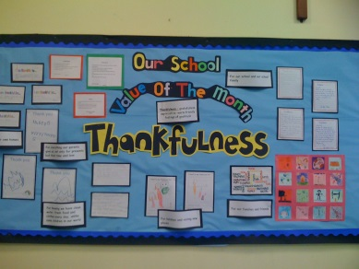

Our hall displays reflect our monthly focus on key values.

The priests of the East Vale Group maintain close contact with the school. The Parish Priest attends school weekly to lead worship. Children attend a celebration of the Eucharist at the parish church or in school every half term.

The daily collective worship, places strong emphasis on Christian and moral themes. Other religions are discussed and studied at relevant times of the year in both key stages. Parents are invited into Class Worship through the year and also are invited along with other community members to Harvest, Christmas and other celebratory school events.

We encourage parents to help us in instilling the key values at home and send out newsletters which specify which values we are focussing on.

**RELATIONSHIPS AND SEXUALITY EDUCATION (RSE)**

The Welsh Government requires that all schools offer a programme of Relationships and Sexuality Education (RSE) to all pupils.  These lessons help learners to move with confidence through childhood and into adolescence.  The school delivers a developmentally appropriate programme to ensure they receive important messages about: relationships and identity; sexual health and wellbeing; empowerment, safety and respect. The focus is very much about helping children to understand how to keep themselves and their body safe.

These lessons build on from the work we do with the children throughout the year around friendships, understanding emotions and how they grow. Many of the lessons are based on the NSPCC PANTS campaign, whose website also has excellent resources for parents/carers to use with their children. If you would like to look at these resources, please go to:  <https://www.nspcc.org.uk/preventing-abuse/keeping-children-safe/underwear-rule/>

**ADDITIONAL LEARNING NEEDS (ALN)**

We like to think that every child has additional learning needs and that these will be met by the education they will receive at Peterston. For children who find that they need extra help, we have well trained, supportive LSAs (learning support assistants) who will work with our pupils on any interventions, from reading and mathematics to emotional support. We also use the skills of our LSAs in class to implement intervention programmes to specific groups of pupils. Alongside this the class teachers plan for differentiation within every day class work. Mrs Sully is the Additional Learning Needs Coordinator (ALNCo) and coordinates all aspects of ALN with all staff. The Additional Learning Needs staff works with our teaching staff so that these children will be helped individually in any way that they may find necessary and individual educational plans are drawn up which indicate specific short term targets and provision for each child. For children who need more help, the ALNCo works closely with other specialists within the Local Authority. Please refer to our ALNCo policy for further details.



**LOOKED AFTER CHILDREN (LAC)**

* The member of staff with responsibility for Looked After Children (LAC) is the Headteacher, Mr Turner.
* The aim is to improve the educational outcomes of looked after children and young people.
* To support Looked After pupils (children in care) to do well in school and maintain their foster placements.
* We liaise with all other agencies i.e. Health, Education, and Social Services to promote their well-being.

**MORE ABLE AND TALENTED PUPILS ( MA&T)**

Sometimes a pupil shows a particular ability or talent in an area of the curriculum or in an extra-curricular activity such as sport or music. In such cases, the school will aim to support that pupil and the family in any way it can by providing specifically differentiated activated and opportunities, offering advice, supporting out of school for training or consulting specialists in the field if deemed appropriate. A bank of resources for more able and talented pupils is available to staff. Teachers use Learning Supports Assistants to help support the learning development of those pupils who are identified as MA&T.

The governors give much importance to this part of the school and are given regular reports by Mr Turner on the subject. A whole school policy has been drawn up and is available for parents to read. A copy of this policy is available on request.

**EQUAL OPPORTUNITES**

Peterston Primary School aims to provide equal opportunities for all, in accordance with our equal opportunities statement.

Education is concerned with the development of the potential of young people within the context of an agreed framework of values. At Peterston super Ely CIW Primary, discrimination of any kind and on any basis is unacceptable. We consider all pupils to be of equal worth. We aim to provide each pupil with the best possible opportunities for his or her future.

It is, therefore, the policy of the school to ensure equality of opportunity for all its pupils, parents, employees and Governors, irrespective of race, ethnicity, nationality, colour, cultural background, language, religious or political beliefs, gender, marital status, family circumstances, socio- economic status or role within the school, sexual orientation, disability, age, HIV or AIDS status and any other grounds or conditions which cannot be shown to be justifiable.

Peterston super Ely CIW Primary is fully committed to equality of opportunity in education and will undertake the implementation of strategies to achieve this.

**DISABILITY EQUALITY**

Peterston super Ely CIW Primary School is an inclusive school which encourages the full involvement of pupils and members of the school, parish, local and wider community with disabilities. Parents, carers, staff, Governors with disabilities or anyone who has children with disabilities are encouraged to share their knowledge, understanding and concerns with us so that we can further improve our service to them. We welcome opportunities to discuss any issues by making an appointment with the Headteacher at any time.

A disability access audit has been undertaken by the LA and the Governing Body has formulated an access plan in accordance with the requirements of the Disability Discrimination Act 2002. This along with the schools Disability Equality scheme is available on request from the school administrator or Headteacher.

**HOMEWORK POLICY**

There is no statutory obligation to provide homework at the primary stage, but homework does encourage pupils to develop perseverance and self-discipline together with the practice of individual study. It also serves to maintain strong links between home and school (developing our Partnership in Education philosophy) by providing parents with a fuller awareness of the work that their child is covering in his/ her class.

The objectives of homework are to:

1. encourage pupils to develop the practice of individual study;
2. develop perseverance and self-discipline;
3. allow practice and consolidation of skills learned in the classroom;
4. permit more ground to be covered and more progress made;
5. utilise materials and sources of information that may not be available in the classroom;
6. involve the family in the learning process.

Parents are requested to assist their children by:

1. being an interactive audience for the child practising reading;
2. encouraging and supporting their child's efforts;
3. testing any work which must be learned e.g. spellings, tables;
4. listening to the child reading what he/ she has written;
5. checking presentation, handwriting and spelling;
6. asking the child to explain what he/ she has been studying;
7. assisting the child in finding the appropriate reference materials.

Additional and optional homework tasks may be set. These will vary week on week, involving different areas of the curriculum. Please see the Homework Policy for further details.

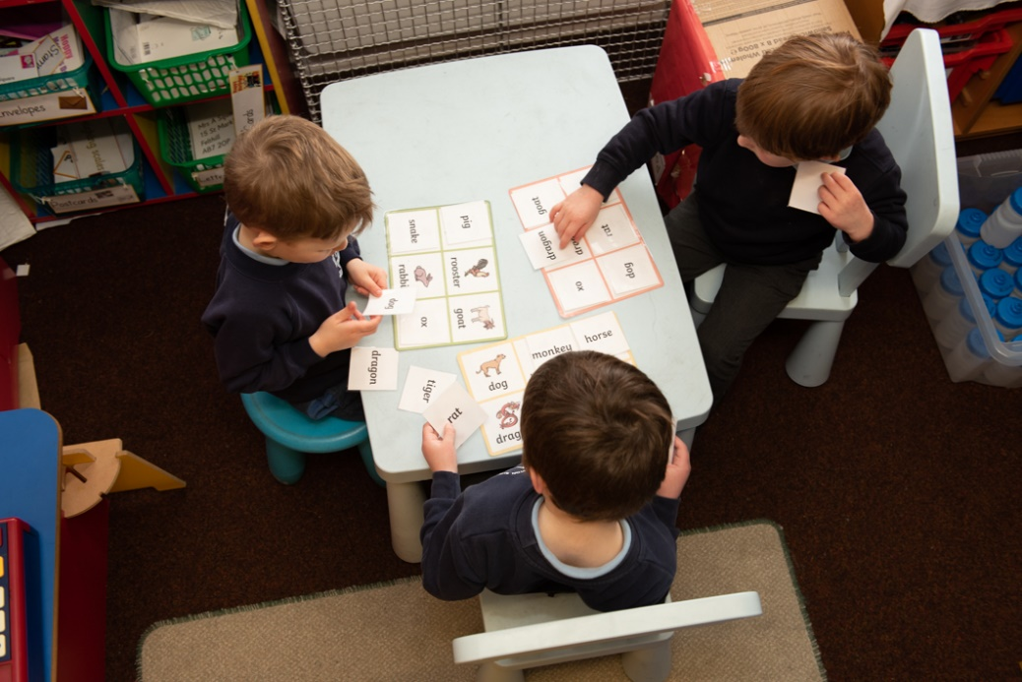

**TESTING AND ASSESSMENT**

The purpose of assessment is to support the progression of each individual learner through the curriculum continuum. Assessment is integral to learning and teaching and it requires effective partnerships among all those involved, including the learner.

Assessment plays a fundamental role in ensuring each individual learner is supported and challenged accordingly. It should contribute to developing a holistic picture of the learner – their strengths, the ways in which they learn, and their areas for development, in order to inform next steps in learning and teaching. Assessment should not be used to make a one-off judgement on the overall achievement of a learner at a set age or point in time against descriptors or criteria on a best-fit basis.

Assessment has three main roles in the process of enabling learner progression:

* supporting individual learners on an ongoing, day-to-day basis
* identifying, capturing and reflecting on individual learner progress over time
* understanding group progress in order to reflect on practice

When a child enters school in Nursery or Reception, we undertake the recommended Foundation Phase baseline profile, as directed by Welsh Assembly. This will enable us to provide a clear picture of each child’s abilities as they enter school and support the early identification of any additional needs.

The school adopts the approach of Assessment for Learning and encourages the child and teacher to work in partnership to improve learning and teaching opportunities. The school is continually developing its procedures to reinforce peer and self-assessment from Foundation Phase to Year 6.

Welsh National Test are carried out up to twice a year. The purpose of these personalised assessments is to support individual learners on an ongoing, day-to-day basis by helping to develop an understanding of strengths and possible next steps in key skills areas, and an understanding of progress over time.

**REPORTING TO PARENTS**

In the autumn and spring terms you will be invited to discuss your child’s progress with individual class teachers. In the summer term, you will have the opportunity to visit an open evening to view your child’s work. An annual written report is sent out to all parents in July.

If you feel your child has any problems whatsoever that are likely to affect his/her life in school, please contact us immediately rather than wait for a parent’s evening to discuss the

problem. Serious matters of concern should be referred to the Headteacher immediately.

Weekly newsletters are sent home via email to keep you informed of events in school. In addition, the SchoolComms texting and e-mail system ensures parents can receive information electronically, and urgent information. Please ensure we have up to date contact details.

**POLICY & PROCEDURE**

**COMPLAINTS PROCEDURE**

The Local Authority's complaints procedure is available in full for parents to read at school and on our school website. This sets out the stages through which parents may proceed if they have a complaint about the Curriculum or Collective Worship in the school, or complaints against individuals.

The stages are outlined as follows:

**Stage 1** Informal Consideration of a Complaint:

We hope that with our open policy, all complaints can be dealt with at this stage, by discussion with Mr Turner and the staff. If the complaint relates to an Authority matter, again it is hoped that informal discussions with the appropriate officer of the Authority would resolve the problem. If not, then parents may proceed to:

**Stage 2** Formal Complaint to the Governing Body:

Parents can write to the Chair of the Governing Body or the Authority. The complaint will then be dealt with by the Governors Complaints Committee. Parents can then make an additional oral statement. If neither of the first two stages resolves the matter, then parents may proceed to:

**Stage 3** Formal Complaint to the Authority:

Parents are required to write to the Assistant Director of Education (Schools). After receiving the written complaint, a panel of three County Councillors will hear the complaint orally.

If parents remain dissatisfied with the outcome, they may refer it to the Welsh Government.

**CHARGING POLICY**

Each term, we take classes on visits that are of educational and social value to the children. These range from a visit to St Fagan’s Museum, to adventurous activities at week’s residential trip to Storey Arm’s.

Under the relevant Education Acts, the school has had to agree a policy on charging for school activities. The Governing Body has drawn up a policy statement of which the main points are:

1. For any activity-taking place mostly outside school hours, we will charge parents the cost of the activity.

2. For any activity-taking place mostly within school hours, we will ask for a voluntary contribution from parents. No child can therefore be excluded from the activity because its parent is unable to or has decided not to pay. Parents will understand though, that unless sufficient contributions are received, it might be impossible to proceed with the activity.

3. Parents can request in writing financial support from the Governing Body in the funding of residential trips in Year 5 and 6.

4. Withdrawal of funding for the Local Authority Schools Music Service by the County Council has meant that the school is no longer able to provide free tuition on musical instruments. However, the Governing Board has decided that tuition of musical instruments may be provided at the school and that there will be some subsidy of funding by the school but the majority of the cost must be met by the parents of those children receiving it.

**POLICY ON CODE OF BEHAVIOUR**

The Governing Body have school policies on code of behaviour and anti-bullying. A copy of each policy is available on the school website for all parents and a copy of each has been given to all members of staff (both teaching and non-teaching), and to all helpers. The aim of the policies is to promote the security, happiness and the opportunities for the children to develop naturally, and it clearly states that bullying has no place in Peterston School.

The policy seeks the support of parents in maintaining high standards of behaviour by the children on the way to and from school, as well as seeking to promote those standards while the children are in the care of the school. The emphasis at Peterston is on the development of self-discipline and mutual respect. The school enjoys a family atmosphere and our pupils are generally very caring and well behaved. The policy emphasises that in promoting the highest standards of behaviour the school will seek to reinforce what the parents are already teaching their children.

Pupils develop school rules each year, which are clearly displayed around the school and are in every classroom. In class these rules are followed along with other class positive behaviour strategies. Children are also awarded house tokens, stickers, house points for good behaviour, courtesy, effort and other achievements both in and out of school. We are looking to develop well-rounded citizens who are equipped to enter the world outside of Peterston.

**ANTI BULLYING**

Our Anti bullying Policy provides clear guidelines for staff, pupils and parents who encounter bullying behaviour and it is available from school upon request. The Headteacher, staff and Governors of Peterston Primary recognise that all children, regardless of individual differences, have an entitlement to a caring, understanding and sympathetic learning environment and to create and maintain such an environment is one of the main priorities of the school. The Schools Council has a role to play in maintaining good behaviour and discouraging bullying and this is made clear to all pupils.

Pupils are encouraged to report incidents of bullying or intimidation to a member of staff, a parent or a member of the School Council and most children feel confident to use this approach. If, however, you feel incidents have not been reported, we would be grateful if you would alert us to them. If a child is experiencing any form of bullying at school it affects upon the whole family, and we would prefer to know about any problems, however minor, as soon as possible to avoid further distress.

**CHILD PROTECTION/SAFEGUARDING**

The school has statutory duty under the Children Act 1989 and the Education Act 2002 to safeguard and promote the welfare of children.

The Governing Body of Peterston is committed to practice, which protects children from harm, and as such, staff and regular volunteers are DBS checked. We accept and recognise our responsibilities to develop awareness if the issues, which cause children, harm and to protect our pupils from all forms of abuse. As such, staff will report any concerns they may have about pupils, to the schools child protection/safeguarding co-ordinator, Mr Owen Turner, Headteacher or the deputy child protection coordinator, Mrs Rachel Glover. The Governor responsible for Child Protection is Mrs L Cross. The school has a detailed and comprehensive Safeguarding and Child Protection policy, which is reviewed with all staff and the Headteacher, leads training in this area. This can be found on the schools website, on the parents’ page.

To safeguard staff we also have a staff wellbeing policy, which is reviewed annually to ensure their continued wellbeing. The health and safety policy details security of the school building and the pupils whilst on school property. The Governors hold health and safety inspections.

The policies above are available on the schools website.

**SCHOOL PREMISES**

We have a Health and Safety governors committee that meets to undertake internal and external inspections and assess any possible risks for pupils, staff and any visitors on site. Our caretaker also undertakes weekly inspections of the site. Fob systems are in place in all main entrances to external buildings. Gates have been installed to restrict access to the playground during the school day. Staff wear identification badges and pupils are reminded of the school rules to ensure their own safety. Please refer to the Health and Safety policy for further details. We have cleaners from the Local Authority cleaning team who work daily, cleaning all areas of the school, including the toilet areas in the main school and outside classrooms.

**PUPIL VOICE/PARTICIPATION**

We encourage as many pupils as possible to become involved in school activities which give them greater knowledge and insight into the world around them. We have an Eco committee, Schools Council, SNAG group, Criw Cymraeg group and Junior Road Safety Officers (JRSOs). All pupils are fully involved in aspects of the schools improvement and represent all pupils within the school. Each year, pupils decide how they would like to support a range of local, national and international charities.

The School Council are elected at the start of the year and represent the children in their classes. They hold regular meetings and focus on aspects of school improvement.

**PARENT TEACHER ASSOCIATION ( PTA)**

The school has a very small dedicated PTA. The association arranges numerous fund- raising activities throughout the year and raises a great deal of money for school funds. The money raised has recently purchased an outdoor learning classroom, new “state of the art” gymnastic bars and games, books and equipment for the classrooms. The money raised always purchases “extra” resources which enrich the curricular provision, thus improving the quality of education provided at the school.

In addition, the PTA encourages close links between staff, parents, local residents and members of the wider community. ***New parents are always welcome and their support is greatly appreciated.***

**UNAUTHORISED ABSENCES**

We are currently not required to publish the unauthorised absences for the last school year, due to the effects of the Covid-19 pandemic. Unauthorised absences at Peterston are due to the school not being notified of an absence.

***“Learning and growing together, to become the best we can be.”***

