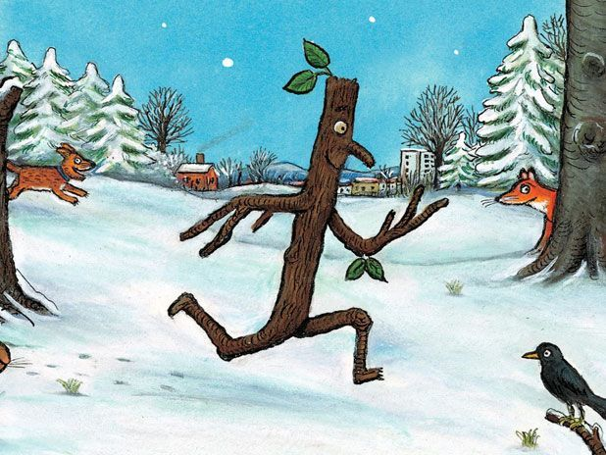

November 6th 2020
Dear Reception Parents,
Welcome back. We hope that you had an enjoyable half term holiday. The children have enjoyed their first week back and have settled in beautifully.
Our topic for this term up until Christmas will be ‘The Enchanted Forest.’ The children have loved their new role play area ‘The Forest Café’ and I am sure they will tell you all about it.
We have enjoyed the story of ‘Stick Man’ this week and the children have made pictures out of sticks and natural materials. We will be talking about how Stick Man felt in the story, making 3D stick men and building a nest for the swans from the story in the forest area of school. We will also be doing lots of literacy and numeracy activities based on the stories ‘The Bear Snores On,’ ‘The Winter Hedgehog,’ and ‘Owl Babies.’ We will be finding out about animals that hibernate and making a potion for the animals in the book ‘The Bear Snores On’ to name a few.
Then, we will move onto a short topic all about Christmas, so there is plenty to look forward to! Please make sure that you read the weekly newsletter from Mr Turner. This week it includes some information about an alternative Christmas concert that we are looking forward to sharing with you.
Through number activities we will be practising counting up to 20, counting backwards from 10, finding 1 more than and 1 less than up to 10, starting to add two small groups of objects together and writing, measuring using blocks, finding the missing numbers on a number line to 10 then 20 and making an owl from 2D shapes. It would be wonderful if were able to practise some of these skills at home when playing games or out and about. Please be guided by your child and the numbers that they are comfortable working with.
Thank you for your support with helping your child to learn the Jolly Phonics sounds and with reading books. You might like to register with ‘Oxford Owl’ which is a free online website where you can access hundreds of ‘Oxford Reading Tree’ e books. The e books also come with fun, interactive activities. We hope that this website will help you to supplement the books that we are sending home fortnightly so that your child can access and practise sounding out many more books at home.
We will be learning colours, numbers, weather, feelings in Welsh and learning some simple Welsh sentences which we will be practising in the role play area.
Our Christian value for the half term is ‘Hope.’ We have started sharing ideas about this value and the children have been talking about this with their friends in simple terms such as what they hope they will do on the weekend or a meal that they hope they will have for tea.
Thank you for sending your child to school in a games kit. The children have games activities with Mr Howells and dance activities in the hall with Mrs Jones. Please make sure they are wearing layers every Wednesday as they will sometimes be using the yard and even in the classroom we keep the door open so that they have access to the reception outdoor area. So wrap up warm!
Thank you for your support. The children are all enjoying being in school and getting to know their new friends and teachers.
The reception team (Mrs Griffiths, Mrs Jones and Mrs Williams)

