Peterston super Ely Church in Wales Primary School
“If you believe you will achieve.”
16.3.20
Dear Parents,
In light of the current situation, and following the announcements made by the Government last night and advice from the Managing Director of the Vale of Glamorgan, we have been reviewing aspects of the school’s operation and have decided to make a number of changes:
- Parent consultations planned for later this term will be postponed
- All trips for this term will be postponed
- Non-essential visitors to school will be stopped
- Collective worship in school will be stopped
- Staff have taken on board additional cleaning measures
- Pupils are being encouraged to wash their hands regularly throughout the day, and follow PHW guidelines (https://phw.nhs.wales/topics/latest-information-on-novel-coronavirus-covid-19/how-to-reduce-the-risk-of-catching-or-spreading-coronavirus/)
We are currently looking at strategies that we could put in place in relation to home learning should schools be required to close. At the moment, we are unable to provide individual “packs” for pupils who are not attending school. The main method of sharing these would be via the class web-pages and Hwb. If you think that you will have difficulty in accessing both of these, please speak to Mr Turner.
We would ask all parents to take their lead from advice available on Public Health Wales website, this information is changing on a daily basis and some guidance previously issued has already been withdrawn. Current advice is: If one person in any household has a persistent cough or fever, everyone living there must stay at home for 14 days.
We would ask that you keep us informed of any absences, this can be done within the SchoolComms app by replying to a message (as you would with a normal text message). Can you please be very clear as to why your child is absent, as this is information is very important for us at the moment.
Please could I also ask that parents try to limit their own visits to school to drop off and pick up of children only.
Thank you in advance for your co-operation and understanding in this matter. Please be assured that we will seek to keep the safety of children, families and staff at the core of our decisions over the next few weeks.
Yours sincerely,
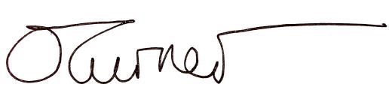
Mr Owen Turner

